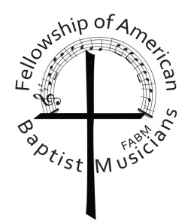

Scholarship Guidelines:

* Scholarships are for the registration fee only.
* A person may receive the scholarship only once.
* A recommendation from your Pastor or Music Director must be included.
* Applicants must be received by May 1st.

Name:___________________________________________________________________________________

Home Address:____________________________________________________________________________

Home City:_______________________________ State:__________________ Zip Code:________________

Home or Cell Phone: ( )

Personal Email:____________________________________________________________________________

Church Name:_____________________________________________________________________________

Church Address:___________________________________________________________________________

Church City:_______________________________ State:___________________ Zip Code:______________

Church Phone: ( )

Church Email:_____________________________________________________________________________

Describe your involvement in your church’s music activities (Use back of form if necessary):

How would attendance at the Conference for Church Musicians benefit you? (Use back of form if necessary)

____________________________________________ _______________________________________

Applicant Signature Date

Please send completed form to: FABM Scholarship

C/O Joyce Crowder

4430 Posthorn Court

Columbus, IN 47203

Fellowship of American Baptist Musicians

Scholarship Application

Child/Youth